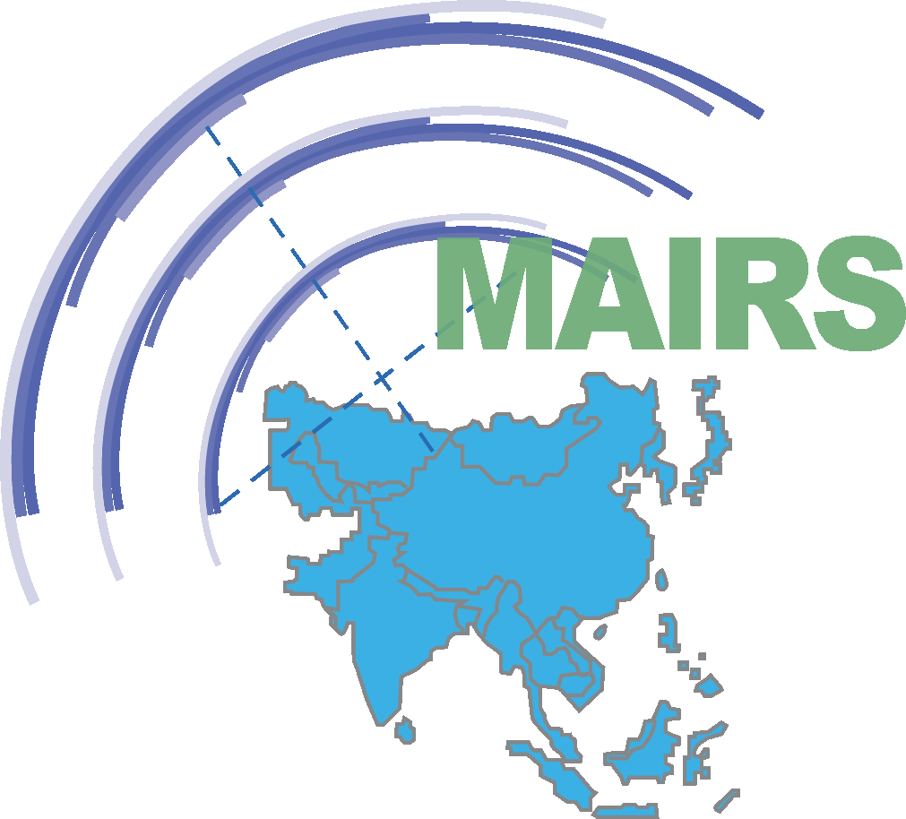
The WCRP ESGF Training workshop for CORDEX Asia
4-5 Dec. 2014
Nanjing University of Information Science and Technology

The Earth System Grid Federation (ESGF) is an international collaboration with a current focus on serving the World Climate Research Programme's (WCRP) Coupled Model Intercomparison Project (CMIP) and supporting climate and environmental science in general. Recently, WCRP is planning to publish CORDEX (Coordinated Regional Climate Downscaling Experiment) outputs to ESGF network. ESGF is an open consortium of institutions, laboratories and centers around the world that are dedicated to supporting research of climate change, and its environmental and societal impact. ESGF will become WCRP main mechanism for exchanging data (including observations, climate simulations and reanalysis data) in the next decade.

During CORDEX East workshop in 11-12 August 2014 in Jeju/Korea, there was strong consensus that ESGF nodes are efficient way to share CORDEX outputs for not only the regional climate scientists but also the IAV sectors. CORDEX Asian groups need technical capacity building on how to build up an ESGF node. A small training workshop was proposed by Monsoon Asia Integrated Regional Study (MAIRS) for CORDEX Asian groups in 4-5 Dec. 2014 in Nanjing University of Information, Science and Technology (NUIST), China. This workshop is jointly supported by MAIRS, WCRP and NUIST.

List of topics for ESGF Training:
1, Introduction to Earth System Grid Federation (ESGF)
What is ESGF?
ESGF Purpose & Limitations

2, Setting up ESGF Node
Hardware / Pre-requisites software / packages requirement
Enable the services of the servers
Installation of ESGF and Configuration of Node

3, Data Publishing on ESGF Node
Directory Structure
Publication Version

4, Data Visualization
Enabled GridFTP, OpenDAP & Thredds Server
Enabled LAS and UV CDAT

5, Data Policies

